HRM-Usecase Description
Manage Wage Change

Table of Contents
1 Use Case Description 3
1.1 Brief Description 3
1.2 Actors and UC Associations 3
2 Pre-conditions 3
3 Post-conditions 3
4 Flow of Events 3
4.1 Basic flow – View information 3
4.1.1 The flow starts: 3
4.2 Alternative Flow 1 – Add new information 4
4.3 Alternative Flow 2 – Edit information 4
The flow starts: 4
4.4 Alternative Flow 3 – Delete information 4
The flow starts: 4
4.5 Alternative Flow 4 – Print data 5
The flow starts: 5
5 Exception Flow 5
5.1 Exception Flow 1 – Add, Edit information 5
5.2 Exception Flow 2– Disconnection database 5
6 Activities Diagram 6
7 Business Rules 7
8 Special Requirements 7

Use Case Description

Brief Description
This use case allows user to Manage Wage Change.
The following flows are described in this document:
- View information
  - Search information
  - Sort information
  - Filter information
- Add new information
- Edit information
- Delete information
- Print data

Actors and UC Associations
Actors:
- Human Resource Planning and Managing Department members
Use Case Associations: depend on Manage Detail Information (If Manage Detail Information doesn’t have info => don’t use function in this use-case)

Pre-conditions
- User must log into HRM system
- User has access Manage Wage Change tab.

Post-conditions
The information is viewed or updated.

Flow of Events

Basic flow – View information

4.1.1 The flow starts:
- User is in a personal information management page and chooses menu “Detail Information management”.
- The system displays a page as described in GUI – Detail Information Management, with all personal information had been stored in HRM system before.
- The flow ends.
4.1.2 Search information
1. User inputs object that needs to search in a text field
2. User chooses “Search” button
3. The system handles and displays the information that user needs
The flow ends.
4.1.3 Sort information
1. User chooses object in a list to sort
2. The system handles and displays the information that user needs
The flow ends.
4.1.4 Filter information
1. User chooses object in a list to filter
2. The system handle and displays the information that user needs.
The flow ends.

Alternative Flow 1 – Add new information
The flow starts:
- User chooses menu “Manage Wage Change”.
- The system displays a tab as described in GUI – Manage Wage Change.
- Click button “add”
- User input data
- User can choose “OK” button or “Cancel” button.
- If user choose “OK” button, data will be saved.
- If user choose “Cancel” button, data won’t be saved.
The flow ends.

Alternative Flow 2 – Edit information

The flow starts:
- User chooses menu “Manage Wage Change”.
- The system displays a tab as described in GUI – Manage Wage Change.
- Choose information need edit
- Click button “edit”
- User can choose “OK” button or “Cancel” button.
- If user choose “OK” button, data will be saved.
- If user choose “Cancel” button, data won’t be saved.
The flow ends.

Alternative Flow 3 – Delete information

The flow starts:
- User chooses menu “Manage Wage Change”.
- The system displays a tab as described in GUI – Manage Wage Change.
- Choose information need delete
- Choose delete this information
- User can choose “OK” button or “Cancel” button.
- If user choose “OK” button, data will be saved.
- If user choose “Cancel” button, data won’t be saved.
The flow ends.

Alternative Flow 4 – Print data

The flow starts:
- User chooses menu “Manage Wage Change”.
- The system displays a tab as described in GUI – Manage Wage Change.
- Choose “print” button
The flow ends.

Exception Flow

Exception Flow 1 – Add, Edit information
- At step 3 of Alternative flows, the user chooses “Cancel” button
- The system displays a message “Do you really close it”
- The actor acknowledges message
- The system closes the message, doesn’t save data and back to personal management page
The flow ends

Exception Flow 2– Disconnection database
- At step 3 of Alternative flows, HRM system disconnects database
- The system displays a message “HRM disconnect”
- The actor acknowledges message
- The system closes the message, back to log in page.
The flow ends

Activities Diagram
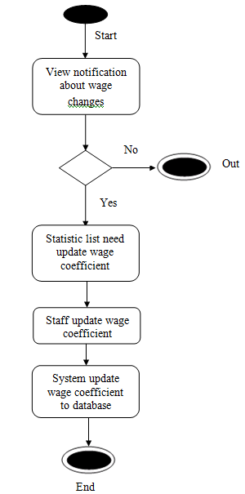
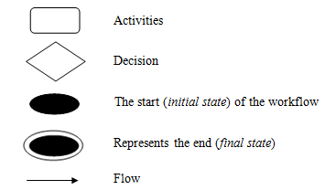

Business Rules

Special Requirements
Use case can satisfy security and performance.

